
THE ROYAL BRITISH LEGION
London Met Branch
NEWSLETTER
‘Accept the challenges so that you can feel the exhilaration of victory.’
(George Patton)

Poppy Appeal as of March 22nd 2011
Met Total = £3, 416, 735.40
National Total = £33, 885, 850.14

March 2011

This is the first newsletter of 2011 and already the year is flying by! All four Metropolitan Counties have held successful conferences and after the Metropolitan Standard Bearers Competition took place in February, Mike Foster from the Richmond Branch in South West County was named as the Metropolitan Standard Bearer and will be representing the Met Region at the National Conference in Telford in May. We would also like to thank all branches for getting their branch accounts and MS1 forms into us. There are still a few accounts and MS1 forms that are outstanding and we would be very grateful if they could be submitted as soon as possible.

Metropolitan Welfare Numbers
. The Welfare team now have permanent telephone numbers.
- General Met Welfare 0203 207 2489

- 0203 207 2491 Wakeel Gbajumo CWO
- 0203 207 2492 Charlotte Ralph CWO
- 0203 207 2493 Kirsten Olufsen CWO
- 0203 207 2494 Michael Guest CSO
- 0203 207 2495 Janusz Kocerba CMA
- 0203 207 2496 Ismet Morshed BMA adviser
- 1203 207 2488 Lynsey Dalton BMA adviser

Be represented at conference
If your branch submitted its MS1 and account forms before the 31st December (or before this year’s extended deadline of Friday 7th Jan) and you ensure that your branch’s affiliation fees are paid by March 31st, then your branch is eligible to send a delegate to conference. All branches who meet these requirements are entitled to send one delegate to conference. Those branches that have over 300 members are eligible to send 2 delegates to conference.

Message from Bob Gamble- Head of Membership
It is always important for the Membership to exercise their enshrined right to influence RBL strategy via their Branch delegates, particularly so this year when we will discuss a number of topics that will together determine the future direction of the organisation.

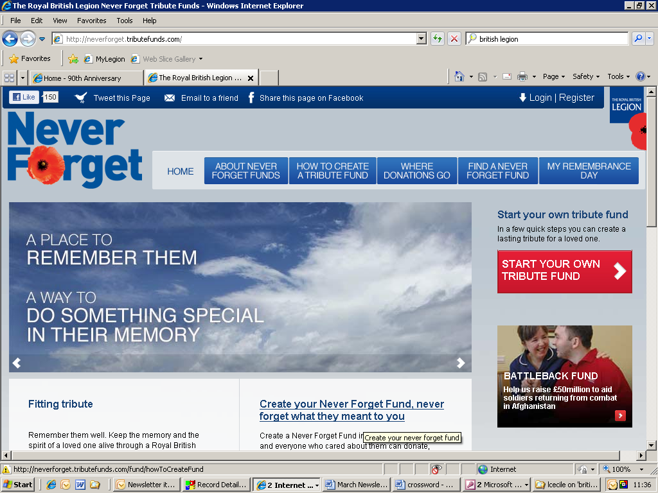
http://neverforget.tributefunds.com/
Visit this new RBL website for details on leaving a lasting legacy for a fallen friend or family member.

DO YOU WANT TO RECEIVE THIS NEWSLETTER VIA YOUR E- MAIL? – THEN PLEASE INFORM THE EDITORS
mhealy@britishlegion.org.uk
lcecile@britishlegion.org.uk

Cricket
T'is the season for sport!
The cricket Inter Service Twenty- Twenty Trophy continues on Tuesday 28th June 2011. This will be the third year in a row that the competition is being hosted at Lords Cricket Ground near Regent’s Park in Central/North London. This year the tournament, which will take place between the The Royal Navy, The Army and The Royal Airforce, will be supporting The Royal British Legion and Help for Heroes. If you would like to enjoy this day of cricket please buy tickets online from www.lords.org/ist20 or via the telephone on 020 7432 1000. Tickets cost £14 for adults, £7 for over 65’s and £5 for under 16s.

Rugby

The famous and exhilarating Army vs Navy Rugby match will be returning to Twickenham Stadium on Saturday 7th May. Tickets for the event can be purchased from any of the links on http://armynavymatch.org/ticket.htm#tickets or by calling ticketmaster on 0844 847 2492. Adults tickets cost between £18 and £20, junior tickets cost £10 and family tickets can be purchased for £40.
Your ticket will not only allow you to watch one of the most exciting matches in the rugby calendar year, but it will also give you access into the warm up matches that take place at Kneller Hall, next door to Twickenham stadium. These matches include the Army Women vs the Royal Navy Women and Army Veterans (Army XXXV) vs Royal Navy Veterans (Ancient Mariners), which both kick off at half ten. The Royal British Legion will be supporting these warm-up matches and we would be delighted if you came along to see us. We hope to recruit many more members through our presence at these warm up games.

Fishing

The inaugural North East London Annual Fishing Competition will be held on Saturday 14th May at Redbridge Lakes (www.redbridgelakes.co.uk), Chigwell Essex. The competition will be run on a handicap system so matter how good you are everyone will have a chance of landing Moby Dick.
The entrance fee is £15 which covers the cost of your peg and a donation to the Poppy Appeal. There will be trophies and prizes so it will be a fun event (except for the fish).
There is a limited amount of pegs so early booking is essential. For booking details, please contact John Hopkins (Vice Chairman Barkingside Branch) by email on Barkingside-rbl@virginmedia.com or telephone 020 8220 7766.
A non-refundable deposit of £8 is required when booking to secure your place.


Golf
To celebrate the 90th Anniversary there will be an RBL National Golf Tournament taking place at Telford Golf Club on Sunday 15th May 2011. There will be both a men’s and women’s tournament with 1st, 2nd and 3rd place prizes awarded in each. On arrival coffee and bacon butties will be served and tee off will take place between 11.30 and 12.15. With 52 spaces available, make sure that you return the form enclosed with this letter and a payment to either Maria or Louis in Haig House Membership Department before Friday 15th April.

90th Anniversary

The Great Poppy Party Weekend
There is set to be a flourish of Poppy Parties across the country on the weekend of the 10th-12th June and this is your chance to join everyone else as they celebrate the 90th anniversary of The Royal British Legion. On the Great Poppy Party Weekend the legion is asking everyone to throw a party and raise a glass to TRBL. Whether your party is a picnic, a dinner party or a wild dancing- till-dawn-knees-up, all we ask is that you make sure you celebrate this special anniversary. For more information and to register your party, please visit www.thegreatpoppypartyweekend.org.uk or ring 01722 214937. You can also buy Poppy Party packs from the Poppy Shop on www.poppyshop.org.uk or 0300 123 9110. These packs are priced at £9 and include picnic supplies, a specially designed table cloth and a booklet of party tips. £5 of the price is donated to TRBL.


The Southwark Cathedral Concert
Make sure that Friday 27th May is clear in your diary for the Southwark Cathedral 90th Anniversary Concert. This is set to be a spectacular evening with music from throughout the decades performed by The Legion’s Central Band. Songs from Abba, Gershwin and Jurassic Park are set to have your foot tapping all evening. Tickets are priced at £10 and are available from your branch secretary.

For Standard Bearers
For those standard bearers that would like to take part in the parade at this event, you should arrive at Haig House, 199 Borough High Street no later than 1700 hours on Friday 27th May. Here there will be changing facilities and tea and coffee. Unfortunately there is no parking at Haig House. The parade will take roughly ten minutes and will start at Haig House and end at Southwark Cathedral. There will be a green room for the standard bearers throughout the concert, however standard bearers are welcome to purchase a ticket, if they would prefer to attend the event or alternatively it is possible to leave after the parade. can leave after the parade.

If you would like to take part in this event, please reply to Toni Isle-Blackmore on 020 7732 8307 or 07956 407747 before 30th April 2011.

Renee’s 90th Daisy Chain
Mrs Irene Brockey, who is the South West MetropolitanCounty Secretary will be honouring the 90th anniversary of the legion by making 90 sponsored daisy chains. If you would like to help Renee by sponsoring a daisy for £1 (or more if you wish) please visit her JustGiving site http://www.justgiving.com/renee-brockey/ or send a cheque payable to the Royal British Legion to;
RBL South West County Office
6 North Street
Isleworth
Middlesex
HA3 0YF
If you are eligible for gift aid, please complete the gift aid application form, that is enclosed with the newsletter and return it along with your cheque.

This week our Metropolitan Anecdote comes from the book “Rank and File- Military and Naval Expressions and their Origins” from Grange Books, which has been kindly loaned to us by Buckhurst Hill RBL Branch.

“Arsenal”
The name of one of London’s most successful football clubs follows a historical trail that takes it back to the Muslim world by way of Woolwich and Venice. The first place to be called anything resembling the English word “Arsenal” was a dockyard area of Venice called “Arsenale” This was derived from a local word arzana, which came in turn from he Arabic dar-accina’ah, meaning ‘a house of mechanical industry’. In due course the industry in question became the making of armaments.

In England, the Royal Aresenal was sited at Woolwich at the end of the seventeenth century. Prior to that Henry VIII had created the Royal Dockyard at Woolwich in 1512, giving this ‘arsenal’ an earlier maritime connection, like that in Venice.

The Woolwich Arsenal Football Club was founded in 1886 and the Arsenal team is still nicknamed ‘the Gunners’ in spite of having moved to Highbury in 1913.
Do you have something to say?
Has something happened in your county or branch that you would like to share with the rest of the region?
Do you have an event coming up that you would like published?
Let Maria or Louis know!
Poppy Shop Order Problems

As you may know, the Poppy Shop website has been down for several weeks.
The website is due to be available by the end of April 2011.

The Poppy Shop is only excepting telephone orders until all of their IT problems are fixed. At present you can call to order 90th Anniversary products and enamel Poppy Lapel Pins.

Call Poppy Shop on 0300 123 9110
in the met!
Branch Training
The Metropolitan Branch Treasurers Course is scheduled to be held on Saturday 30th and Sunday 31st July at Haig House, 199 Borough High Street, London SE1 1AA. There are still places available so please contact us to reserve a spot.
We are also looking to hold a Branch Management Course in future. The course is of particular use to new Branch Secretaries and officials to learn about running a Branch. To ensure this training event can be held we require a minimum of a 10 people.
Please contact us if you are interested in this course.

DATES FOR THE DIARY
Saturday 7th May- Army Navy Rugby at Twickenham
Sunday 15th May- Telford Fun Day at Telford Park
Thursday 19th May - Telford 90th Anniversary Gala dinner
Saturday 21st- Sunday 22nd May- National Conference Telford
Friday 27th May- Southwark Cathedral Concert
Friday 10th- Sunday 12th June- The Great Poppy Party Weekend
Tuesday 28th June- IST cricket at Lord’s

Crossword Answer
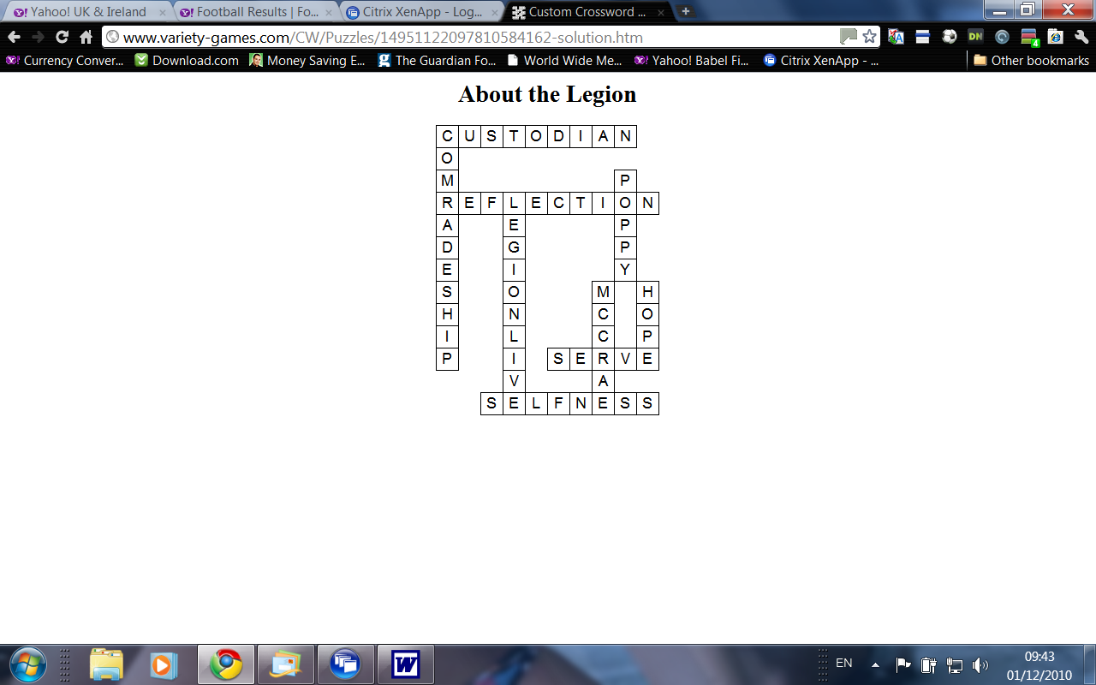

To stand a chance of wining a traditional limited edition brown Royal British Legion tie, please answer the following question:

What weekend is The Great Poppy Party being held?

Please send your answer by email or send via post to us at RBL, Haig House, 3rd Floor, 199 Borough High St, London SE1 1AA.

